**Experiment 3.2**

**Name :- Yash Gupta Uid :- 20BCS5009**

**Course :- CSE Section :- 709-A**

**Subject :- Programming in Python Subject Code :- 20CSP-259**

**Aim :-**

1. Write a Python class named Student with two attributes student_id, student_name. Add a new attribute student_class and display the entire attribute and their values of the said class. Now remove the student_name attribute and display the entire attribute with values
2. Write a Python class to find a pair of elements (indices of the two numbers) from a given array whose sum equals a specific target number.
3. Write a Python class named Rectangle constructed by a length and width and a method which will compute the area of a rectangle
4. Write a Python class named Circle constructed by a radius and two methods which will compute the area and the perimeter of a circle
5. Write a Python program to crate two empty classes, Student and Marks. Now create some instances and check whether they are instances of the said classes or not. Also, check whether the said classes are subclasses of the built-in object class or not

**Code :-**

class Student:

student_id = 'V10'

student_name = 'James'

print("Original attributes and values of class:")

for attr, value in Student.__dict__.items():

if not attr.startswith('_'):

print(f'{attr} -> {value}')

print("\nAfter adding student_class, attributes and values ")

Student.student_class = 'V'

for attr, value in Student.__dict__.items():

if not attr.startswith('_'):

print(f'{attr} -> {value}')

print("\nAfter removing student_name, attributes and values ")

del Student.student_name

#delattr(Student, 'student_name')

for attr, value in Student.__dict__.items():

if not attr.startswith('_'):

print(f'{attr} -> {value}')

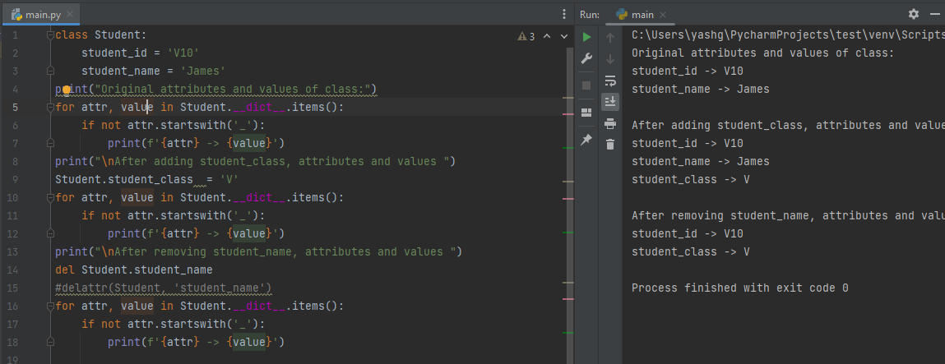

**2.**

class pair:  
 def twoSum(self, nums, target):  
 lookup = {}  
 for i, num in enumerate(nums):  
 if target - num in lookup:  
 return (lookup[target - num], i )  
 lookup[num] = i  
print("index1=%d, index2=%d" % pair().twoSum((30,60,80,90,20,60,40),90))

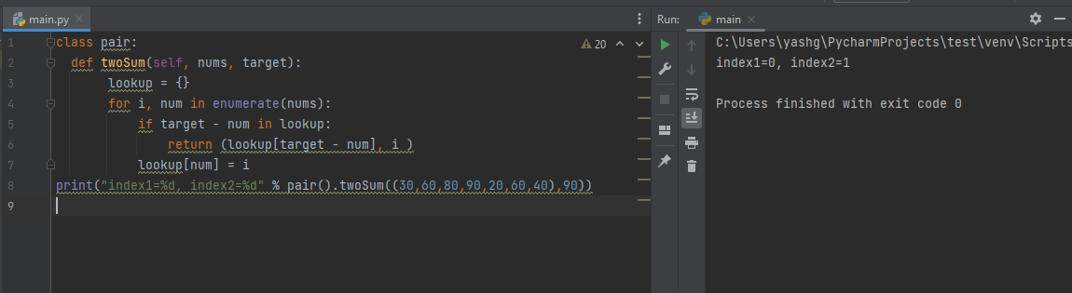

**3.**

class Rectangle():  
 def __init__(rec, a, b):  
 rec.length = a  
 rec.width = b  
  
 def rectangle_area(rec):  
 return rec.length*rec.width  
  
newRectangle = Rectangle(15, 20)  
print("Area : ",newRectangle.rectangle_area())

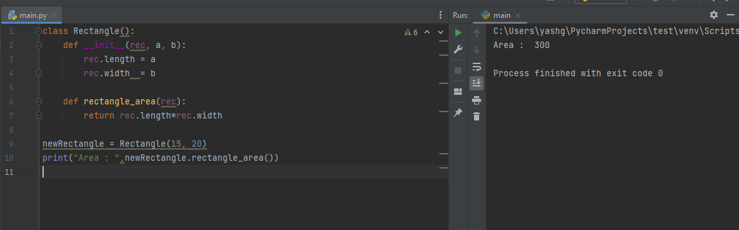

**4.**

class Circle():  
 def __init__(cir, r):  
 cir.radius = r  
  
 def area(cir):  
 return cir.radius ** 2 * 3.14  
  
 def perimeter(cir):  
 return 2 * cir.radius * 3.14  
  
  
NewCircle = Circle(8)  
print("Area : ", NewCircle.area())  
print("Perimeter : ", NewCircle.perimeter())

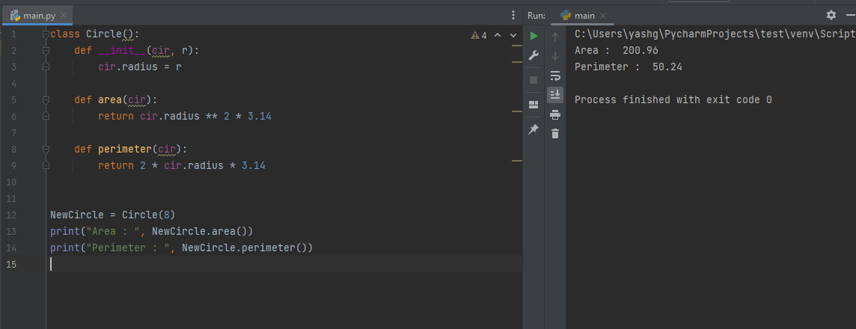

**5.**

class Student:  
 pass  
class Marks:  
 pass  
student1 = Student()  
marks1 = Marks()  
print(isinstance(student1, Student))  
print(isinstance(marks1, Student))  
print(isinstance(marks1, Marks))  
print(isinstance(student1, Marks))  
print("\nCheck whether the said classes are subclasses of the built-in object class or not.")  
print(issubclass(Student, object))  
print(issubclass(Marks, object))

